Report #1 is a list of deliveries with the suppliers and dates of expected and actual delivery dates of supplies. This report lists what the time gap is between the two dates and gives the winery an idea if our supplies are arriving in a timely manner. This report is grouped by month with individual records falling in chronological order.

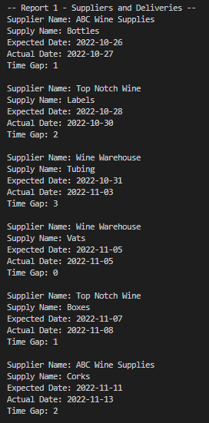

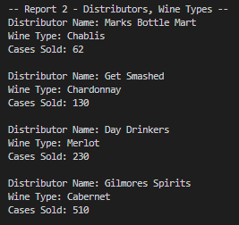

Report #2 is a list of information about the distributors and wine types. The name of the distributor and the wine type supplied by that distributor are two of the three columns displayed here, and the other is the number of cases sold for each distributor and wine type. The results are ordered by the number of cases sold, so the wine being sold the least will appear at the top of the results.

Report # 3 is a report of employee hours worked listed by quarters. This supplies the winery with a quarterly list of who is putting in the hours needed for purposes of possible bonuses 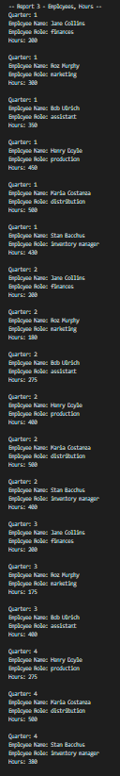based on contribution level.